**Research and Preparation for Extended Response 2**

**Respiratory Diseases**

You must research the following respiratory diseases:

* emphysema
* lung cancer
* pneumonia
* asthma

You will have one period of class time to conduct this research and will then be required to answer a series of short answers on THREE of these diseases.

The questions will require you to compare and contrast the diseases. The questions will be based around the following:

* causes / risk factors / triggers
* prevalence (how common are the diseases)
* symptoms
* effects on gas exchange.

You will also be asked to interpret some data on measuring lung volumes in individuals with lung disease. In particular you should be able to determine lung volumes from a spirometer and also calculate forced expiratory volume per second (FEV1). The attached sheet will help you with some of this work.

This assessment will be completed in-class under closed book test conditions. Ensure that you bring a calculator, pencil and a ruler with you, along with your usual writing equipment.



#### HUMAN BIOLOGICAL SCIENCES STAGE 2

## **RESPIRATORY DISEASES**

**EXTENDED RESPONSE 2**

Name: ___________________________________

**Respiratory Diseases: Extended Response 2**

**Part A – Lung Diseases**

Answer the following questions with respect to the diseases:

* emphysema
* pneumonia
* asthma

Write your answers on the lined paper below and over the page.

1. For each disease state the part of the respiratory system that is mainly affected and what happens to the affected part during the disease. [3]
2. All three diseases affect the body’s ability to exchange gases. For each disease explain why less oxygen passes from the lungs into the blood. [3]
3. List at least three likely causes (or triggers) for each disease. [3]
4. Give the prevalence for each disease in Australia [1]. Choose from the following:

4 in 1000, 3 in 100, 1 in 10

**Part B starts on the next page.**

**Part B – Measuring Lung Volumes**

Write your answers in the spaces provided.

1. From the spirogram below determine the person’s tidal volume (TV), vital capacity (VC) and residual volume (RV). [3]

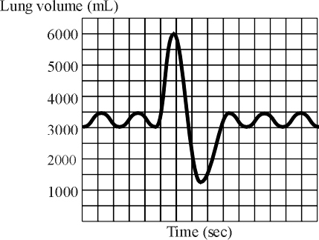

Tidal volume = __________

Vital capacity = __________

Residual volume = __***______***__

1. Below is a spirogram from a person who suffers from asthma. Use this graph to help answer parts (a) and (b).

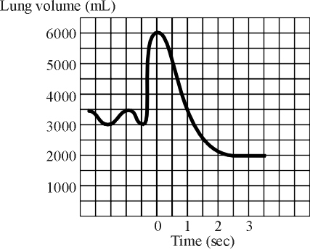

(a) Calculate the person’s FEV1. [1]

(b) In a healthy person FEV1 should be more than 80% of the person’s vital capacity. For this asthma sufferer, calculate his FEV1 as a percentage of vital capacity. [1]

**END OF ASSESSMENT**

**Answer Key**

Part A

1. Emphysema – reduces number of alveoli [1]

Pneumonia – fluid build up in the alveoli [1]

Asthma – bronchioles constrict and fill with mucous [1]

1. Emphysema – decreases surface area for gas exchange [1]

Pneumonia – increases distance over which gas must diffuse [1]

Asthma – reduces airflow to and from the alveoli [1]

1. Emphysema – asbestos / smoking / prolonged exposure to coal or silica

Pneumonia – bacteria / viruses / inhaling vomit / irritating fumes (e.g. petroleum)

Asthma – respiratory infection / allergens (e.g. dust, pollen), exercise, irritants (e.g. smoke, perfume), medicinces (e.g. aspirin), emotional upheaval, food additives

1. Pneumonia 3 in 100

Emphysema 4 in 1000

Asthma 1 in 10

Part B

Tidal volume 500 mL

Vital capacity 4750 mL

Residual volume 1250 mL

FEV1 2500 mL

2500/4000x100 = 62.5%